**Objetos de Prueba**

**Objeto 1**

Imagen del Objeto

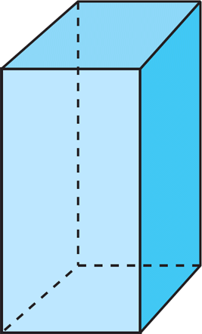

Código esperado OBJ (Puntos pueden cambiar de valor, pero se debe mantener la relación)

(Lista de puntos)

v 0 0 0 0

v 1.5 0 0 0

v 0 1.5 0 0

v 1.5 1.5 0

v 0 0 0 3.8

v 1.5 0 3.8

v 0 1.5 3.8

v 1.5 1.5 3.8

(Matriz de adyacencia)

f 4 3 2 1

f 2 6 5 1

f 3 7 6 2

f 8 7 3 4

f 5 8 4 1

f 6 7 8 5

**Objeto 2**

Imagen del Objeto

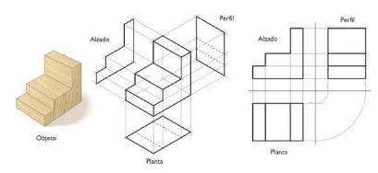

Código esperado OBJ (Puntos pueden cambiar de valor, pero se debe mantener la relación)

v 0.880481 0.464949 -0.677763

v 0.880481 0.464949 0.677763

v -0.880481 0.464949 0.677763

v -0.880481 0.464949 -0.677764

v 0.880481 0.094926 -0.677763

v 0.880480 0.094926 0.677764

v -0.880481 0.094926 0.677763

v -0.880481 0.094926 -0.677763

v -0.489891 0.464949 -0.677764

v -0.489892 0.464949 0.677763

v -0.489891 0.094926 -0.677763

v -0.489892 0.094926 0.677763

v 0.474691 0.464949 -0.677763

v 0.474691 0.464949 0.677763

v 0.474691 0.094926 -0.677763

v 0.474690 0.094926 0.677764

v -0.489891 0.800542 -0.677764

v -0.880481 0.800542 -0.677764

v -0.489892 0.800542 0.677763

v -0.880481 0.800542 0.677763

v 0.474691 0.800542 -0.677763

v 0.474691 0.800542 0.677763

v -0.489891 1.420943 -0.677764

v -0.880481 1.420943 -0.677764

v -0.489892 1.420943 0.677763

v -0.880481 1.420943 0.677763

vn 0.0000 0.0000 -1.0000

vn 0.0000 1.0000 0.0000

vn -1.0000 0.0000 -0.0000

vn 1.0000 -0.0000 0.0000

vn -0.0000 0.0000 1.0000

vn 0.0000 -1.0000 0.0000

usemtl Material

s off

f 14//1 10//1 19//1 22//1

f 11//2 8//2 7//2 12//2

f 1//3 5//3 6//3 2//3

f 10//1 12//1 7//1 3//1

f 3//4 7//4 8//4 4//4

f 11//5 9//5 4//5 8//5

f 15//5 13//5 9//5 11//5

f 14//1 16//1 12//1 10//1

f 15//2 11//2 12//2 16//2

f 13//3 14//3 22//3 21//3

f 1//6 2//6 14//6 13//6

f 5//2 15//2 16//2 6//2

f 2//1 6//1 16//1 14//1

f 5//5 1//5 13//5 15//5

f 17//3 19//3 25//3 23//3

f 21//6 22//6 19//6 17//6

f 3//4 4//4 18//4 20//4

f 10//1 3//1 20//1 19//1

f 4//5 9//5 17//5 18//5

f 9//5 13//5 21//5 17//5

f 23//6 25//6 26//6 24//6

f 19//1 20//1 26//1 25//1

f 20//4 18//4 24//4 26//4

f 18//5 17//5 23//5 24//5

**Objeto 3**

Imagen del Objeto

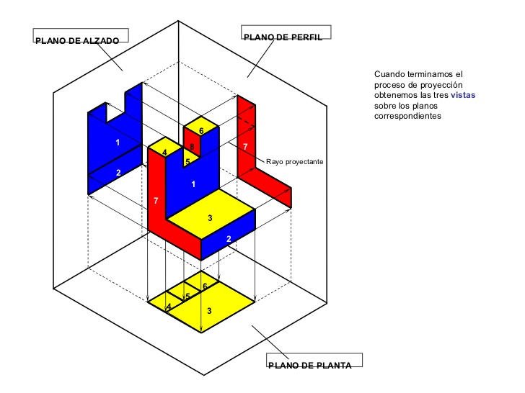

Código esperado OBJ (Puntos pueden cambiar de valor, pero se debe mantener la relación)

v -2.545907 1.100336 -0.558651

v -2.545907 1.477723 -0.558651

v -2.545907 1.100336 0.565880

v -2.545907 1.477723 0.565880

v -3.743957 1.100336 -0.558651

v -3.743957 1.477723 -0.558651

v -3.743957 1.100336 0.565880

v -3.743957 1.477723 0.565880

v -2.545907 1.477723 0.180012

v -2.545907 1.100336 0.180012

v -3.743957 1.477723 0.180012

v -3.743957 1.100336 0.180012

v -2.934164 1.477723 0.565880

v -2.934164 1.100336 0.565880

v -2.934164 1.477723 -0.558651

v -2.934164 1.100336 -0.558651

v -2.934164 1.477723 0.180012

v -2.934164 1.100336 0.180012

v -3.339061 1.477723 0.565880

v -3.339060 1.100336 -0.558651

v -3.339060 1.100336 0.180012

v -3.339061 1.100336 0.565880

v -3.339060 1.477723 -0.558651

v -3.339061 1.477723 0.180012

v -2.545907 1.100336 0.180012

v -3.743957 1.477723 0.180012

v -2.545907 1.477723 0.180012

v -3.743957 1.100336 0.180012

v -2.934164 1.100336 0.180012

v -2.934164 1.477723 0.180012

v -3.339061 1.477723 0.180012

v -3.339060 1.100336 0.180012

v -2.545907 2.657869 0.180012

v -2.545907 2.657869 0.565880

v -3.339061 2.657869 0.565880

v -3.743957 2.657869 0.565880

v -3.743957 2.657869 0.180012

v -2.934164 2.657869 0.180012

v -2.934164 2.657869 0.565880

v -3.339061 2.657869 0.180012

v -3.339061 2.275414 0.180012

v -2.934164 2.275414 0.180012

v -2.934164 2.275414 0.565880

v -3.339061 2.275414 0.565880

vn 1.0000 0.0000 0.0000

vn -0.0000 0.0000 1.0000

vn -1.0000 0.0000 -0.0000

vn 0.0000 -1.0000 0.0000

vn 0.0000 1.0000 0.0000

vn 0.0000 0.0000 -1.0000

usemtl None

s off

f 9//1 4//1 3//1 10//1

f 19//2 8//2 7//2 22//2

f 26//3 6//3 5//3 28//3

f 21//4 22//4 7//4 12//4

f 17//3 13//3 39//3 38//3

f 30//5 17//5 9//5 27//5

f 32//4 21//4 12//4 28//4

f 15//6 2//6 1//6 16//6 20//6 5//6 6//6 23//6

f 27//2 9//2 10//2 25//2

f 25//2 10//2 18//2 29//2

f 31//2 24//2 17//2 30//2

f 19//2 13//2 43//2 44//2

f 10//4 3//4 14//4 18//4

f 4//2 13//2 14//2 3//2

f 19//1 24//1 40//1 35//1

f 26//2 11//2 24//2 31//2

f 29//2 18//2 21//2 32//2

f 18//4 14//4 22//4 21//4

f 13//2 19//2 22//2 14//2

f 2//1 27//1 25//1 1//1

f 6//5 26//5 31//5 30//5 27//5 2//5 15//5 23//5

f 11//2 26//2 28//2 12//2

f 29//4 32//4 28//4 5//4 20//4 16//4 1//4 25//4

f 38//5 39//5 34//5 33//5

f 37//5 36//5 35//5 40//5

f 8//2 19//2 35//2 36//2

f 24//6 11//6 37//6 40//6

f 13//2 4//2 34//2 39//2

f 9//6 17//6 38//6 33//6

f 4//1 9//1 33//1 34//1

f 41//5 44//5 43//5 42//5

f 13//1 17//1 42//1 43//1

f 24//3 19//3 44//3 41//3

f 17//6 24//6 41//6 42//6

f 11//3 12//3 7//3 8//3 36//3 37//3

**Objeto 4** Por definir.

**Objeto 5** Por definir.

**Objeto 6** Por definir.

**Dispositivos móviles**

**Gama media #1**

Android 9.0 Equipo Xiaomi Redmi 6 3GB RAM, 32 GB ROM, Procesador Mediatek Helio P22 Octa-Core, 13 MP Trasera 5 MP Frontal.

**Gama media #2**

Android 8.0 Equipo Moto G5 3GB RAM, 32 GB ROM, Procesador Mediatek 1.4Ghz Quad-Core ARM Cortex-A53, 13 MP Trasera 5 MP Frontal.

**Gama alta #3**

Android 9.0 Equipo Xiaomi Redmi Note 8 6GB RAM, 128 GB ROM, Procesador Snapdragon 665 Octa-Core de 2GHz, 48 MP Trasera 13 MP Frontal.

**Ambientes para captura de fotografías**

**Ambiente #1**

Fondo blanco, ambiente controlado.

**Ambiente #2**

Mesas laboratorio de electrónica, ambiente no controlado.